**Ideation Phase**

**Empathize & Discover**

|  |  |
| --- | --- |
| Date | 26 June 2025 |
| Team ID | LTVIP2025TMID34763 |
| Project Name | Pollen's Profiling: Automated Classification of Pollen Grains |
| Maximum Marks | 4 Marks |

**Empathy Map Canvas:**

An empathy map is a simple, easy-to-digest visual that captures knowledge about a user’s behaviours and attitudes.

Empathy allows us to see the world through the eyes of our users—environmental scientists, medical professionals, and agricultural researchers. By understanding their challenges, emotions, and goals, we can create a solution that is not just functional, but truly helpful and human centered .

**Example:**

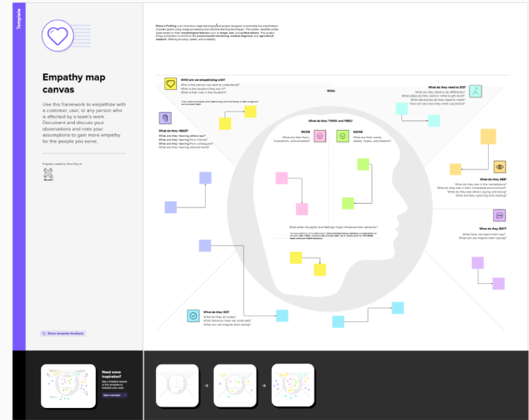

**Example:** 